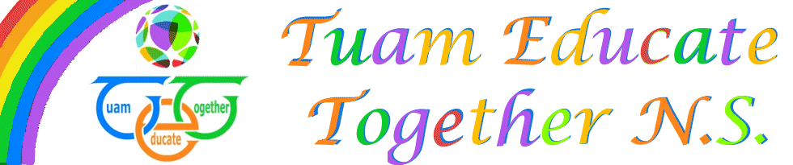

Board of Management Agreed report

Meeting 11, 29th September, 2022

- New enrolments were brought to the board.
- Policy ratification: Child protection and AntiBullying, Administration of medicines and Homework policy
- Information on schools and budget shared
- Revision of Salaries and Annual leave arrangements for school secretaries discussed.
- PA report presented

