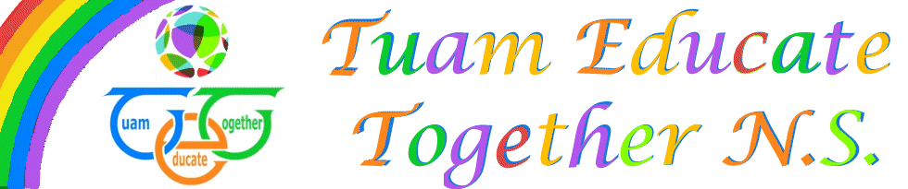

Board of Management Agreed report

Meeting 7, October 7th, 2021

- Enrollments confirmed at 178-One developing post granted.
- Interview will take place in October for Maternity Leave and POR
- SNA appeal submitted for a 2nd time.
- Policies ratified: Child Protection and Anti Bullying
- Finances presented to the board
- Parents Association report presented

