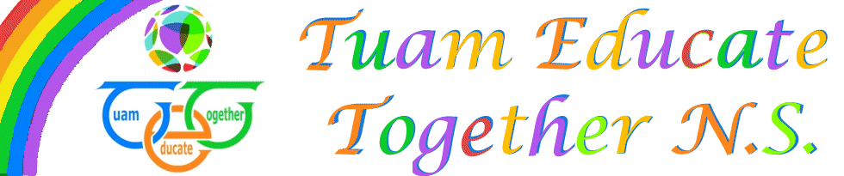

Board of Management Agreed report

Meeting 9, April 6th, 2022

- Awaiting Exceptional Review, 16th in line, gathering information from parents,
- Child Protection report was presented.
- Valeo charity partners have gathered €11,000 for Tuam ETNS!
- Financial report presented to the board
- Parents Association report presented

