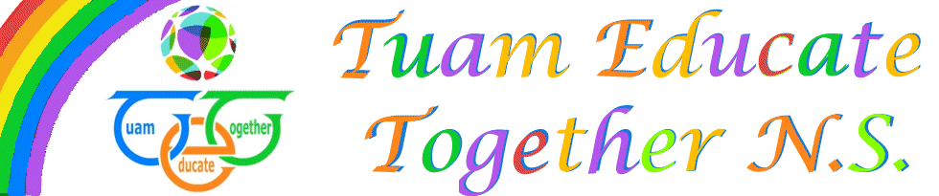

Board of Management Agreed Report

Meeting 3 on October 7th, 2020

- Reviewed the child protection policy.

- Report on student numbers and staffing discussed

- In correspondence: Resignation letter received, maternity letter received and leave of absence applied for.

- Covid 19 policy discussed, grants used to cleaning products,staff cleaning regimes discussed and new cleaner discussed.

