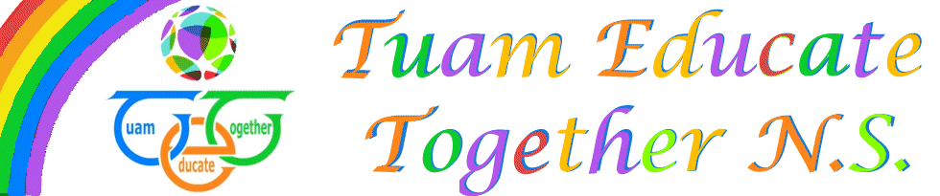

Board of Management Agreed report

Meeting 8, December 9th 2021

- Department confirmed 2nd developing school for school year
- One Bullying incident was reported to the board. Under supervision
- Write to Read training has been very successful.
- Finances presented to the board
- Parents Association report presented

