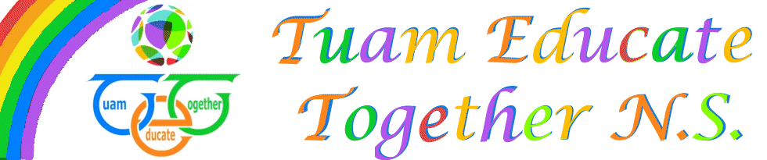

Board of Management Agreed report

Meeting 10, 14th June, 2022

- Board approved Junior Infant enrolment increase for this year only to reach developing post in Sept, therefore avoiding split class.
- No child protection or bullying to report
- Active month in operation- Family funday and student CD ready to be rolled out.
- Parents Association working very hard for our first Graduation

