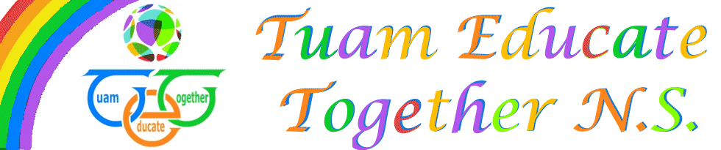

Board of Management Agreed report

Meeting 12, Dec 15th, 2022

- Applications for funding assessments were brought to the board
- Child Protection oversight report was discussed
- Building maintenance and plumbing issues discussed
- School financial report presented
- PA report presented

